Section 1
TITLE OF PAPER (14 Points Times New Roman)
……………………… ……………… ………………. ………………

Author^{1,}*; Author^{2,†;} Author^{2,†} ; Author³ [Not more than six authors]
1.Author First Name , Middle Name Last Name Qualifications, Designation,
Full Departmental address District, Postal Pin Code, State (Country)
(E-Mail & Mobile No.: xyz@abc.xxxx (Mobile number)
2.
3.
4.
5.
6.

Corresponding Author ( Note:
*Full Name …………………………..., Qualifications,…………………………………
Designation …………………………………….
Department ,,,,,,,,,,,,,,,,,,,,,,
Name of College / Institution ……………………………………………..
Full Address ………………………………………..
Postal Pin Code : ……………State: (Country: )
*E-Mail: of Corresponding Author.
(Mobile Number………………… WhatsApp No: __________________)
Section 2: Abstract (Word Limit not exceeding 300 words) and Keywords (4 to 6 words).

Abstract: (Constructed Abstract) The IMRAD Format (see table below for IMRAD format)
Introduction /( Background): ……………………………………… … …………… …………. ………… …………….. ……………… ………………….. ……………. …………..
……………………………………… … …………… …………. ………… …………….. ……………… ………………….. ……………. …………..
Material and Methods: ……………………………………… … …………… …………. ………… …………….. ……………… ………………….. ……………. …………..
Results: ……………………………………… … …………… …………. ………… …………….. ……………… ………………….. ……………. …………..
Discussion: (Two to three lines only)……………………………..
………………… . . …………. …………………… ……………………. ………..
Conclusion: ……………………………………… … …………… …………. ………… …………….. ……………… ………………….. ……………. …………..
Keywords: ……………………………………… … …………… ………….
(Word Limit: 4 to 6 Key words be arranged in alphabetic order)

The IMRAD Format of Main Sections of a Scientific Research / Review paper
Reference; www.springer.com/cda/content/document/cda.../9783319031002-c2.pdf?SGWID...as accessed on 11-7-2017
Title | Full Title of paper
Authors | Full Names, Qualifications and affiliations of authors- with full postal address email ID and ( Contact Number- Mobile and Land Line)
Abstract | A stand-alone, short narrative of the paper- IMRAD style ( Intro; Material Methods;Results; And Discussion) Conclusions
Keywords | Words other than those in title that best describe the paper
Introduction | Why this paper? The problem, what is not known, the objective of the study
Materials and methods | How was the study done?
Results | What did you find
Discussion | What does it mean? What next? Interpretation of results and  future directions
Conclusion | Possible implications?
Acknowledgments | Who helped and how; what was the funding source?
References | Details of papers and Books etc cited
Appendices | Supplementary materials

Section 3
Short Running Title- Right page header of Journal: ……………….
Short Running Title- Left page header of Journal: ……………….

Citation of book or Article | Short Running Title- Right page header of Journal:  Not more than 5 to 12 words ( 80 Characters) | Authors Initials on left page header of Journal:
Surgical and Para-surgical Techniques for Correction of Trichiasis and Entropion: Under-recognized Contribution of Ancient India  Ruby Kumar; Manoj Kumar  J Res Educ Indian Med. 2017; 23(2): 109-112  » Abstract » PDF» doi: 10.5455/JREIM.82-1504368444 | Surgical and Para-Surgical Techniques for Correction of Trichiasis and Entropion  This Example has about [( 11 words) and ( 76 Characters) | Ruby Kumar and Manoj Kumar  (Example for 2 Authors)
Advances in Research and Education in Ayurveda (containing Alphabetic listing of PG & PhD. theses in Seven Specialties of Ayurveda.)  Suresh Kumar, Ramanath dwivedi and Shriram Sharma (1988) JREIM Publications, Varanasi (India) | ADVANCES IN RESEARCH AND EDUCATION IN AYURVEDA | Suresh Kumar, Ramanath Dwivedi and Shriram Sharma  (Example for 3 Authors)
ADVANCES IN HEPATOLOGY - RECENT RESEARCHES IN AYURVEDA  SURESH KUMAR, V. N. PANDEY, GURDEEP SINGH, K. P. SINGH, G. N. CHATURVEDI  J Res Educ Indian Med. 1982; 1(1): 35-41  » Abstract »  (available Free- online from editor JREIM) | ADVANCES IN HEPATOLOGY - RECENT RESEARCHES IN AYURVEDA  Running Title for Right Page Header will be | Suresh Kumar et al.  Running Title Left Page Header for more than 3 authors

Section 4

Key Message (If any): …………….. . ……………………. …………………

Acknowledgments
The author would like to acknowledge the – other than those who are Authors/co-authors.
Conflicts of Interest The authors declare conflict of interest if any in full details.
Source of Funds/ Grants (if any) ________Give s/ attach detail__________

Continued on page 3
Section 5 (Manual numbering required) No Auto numbering. [Quote references in the running text of article as per sample paper]

References [Same as submitted in /with the initial article/mms]
1.
2.
3.

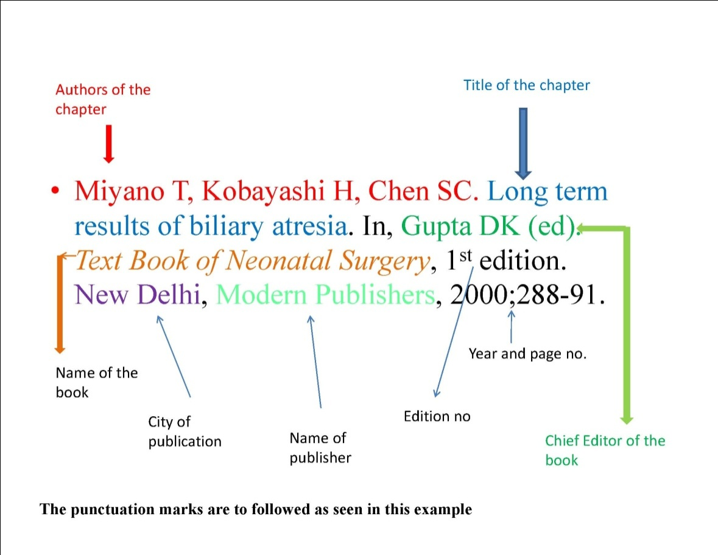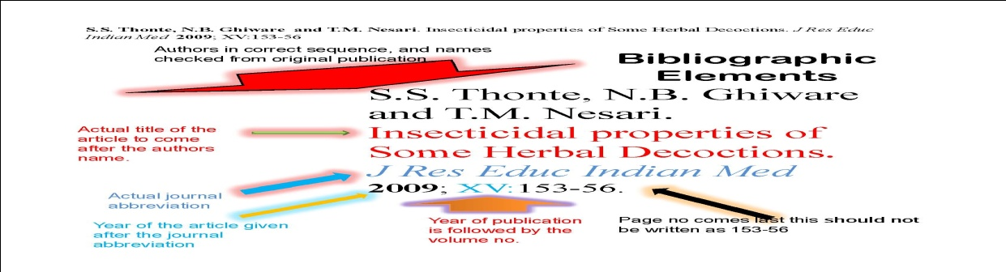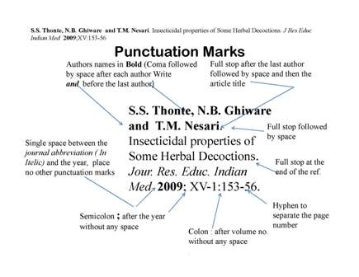
Section 6:
For JREIM Office Use Only
Abstract : Received: /
Acceptance letter by email on dated/…………………. {through ejmanager.com // system}.
Full Paper Received on
Revised-on :/
Accepted:on ________________________
Published online First on:_____________________
© 2021 JREIM; http://www.jreim-ayushjournal.com

Annexure 1 additional for JREIM authors
Reference (in modified JREIM- PubMed style) (Sorted in alphabetic order )
The following references are as examples but are useful references of Ayurveda texts/Samhitas.
Authors can copy and keep for use and record.
EXAMPLES from AYURVEDA
Acharya Y.T., Rasamritam, (3:87), pg. 33, Motilal Banarasi Das, Banaras, Varanasi (1951)
Acharya Y.T., Rasamritam, (3:88-94), pg.34, Motilal Banarasi Das, Baranasi, (1951)
Acharya Y.T., Siddhyogsamgraha , 11th ed. 1st chapter (Jwara-adhikara), pg. 4, Shri Baidyanatha Ayurved Bhavan Ltd, Patna, (1995)
Acharya Y.T., Siddhyogsamgraha, 11th ed. 1st chapter (Jwara-adhikara), pg. 4, Shri Baidyanatha Ayurved Bhavan Ltd, Patna, (1995
Agnivesha, Charaka Samhita , Ayurveda-Dipika commentary by Chakrapanidutta, revised ed., Sutra Sthana ( 26:43), pg. 145, Chaukhambha Surbharati Prakashan, Varanasi (2005)
Agnivesha, Charaka Samhita, Ayurveda-Dipika commentary by Chakrapanidutta, revised ed., Nidana Sthana ( 4:45- 46), pg. 215, Chaukhambha Surbharati Prakashan, Varanasi, (2005)
Agnivesha, Charaka Samhita, Ayurveda-Dipika commentary by Chakrapanidutta, revised ed., Nidana Sthana (4:37), pg. 215, Chaukhambha Surbharati Prakashan, Varanasi (2005
American Diabetes Association, Diabetes Care, Report of the Expert Committee on the diagnosis and classification of diabetes mellitus, July ; 20(7) :1183–97, (1997)
Baragi UC. A study on Trividha Upasthambha w.s.r. to Ahara in Bruhatrayee. R.G.U.H.S. Bangalore, Karnataka, M.D. Thesis 2008
Bhavamishra, Bhavaprakasha Nighantu, Vidyotini, hindi commentary by Sri Bhramashankara Mishra & Rupalalji Vaisya , 10th ed. Part-I, Madhu Varga, (25) , pg. 791, Chaukhambha Bharati Academy, Varanasi, (2002)
Bhavamishra, Bhavaprakasha Nighantu, Vidyotini, hindi commentary by Sri Bhramashankara Mishra & Rupalalji Vaisya , 10th ed. Part-I, Guduchyadi Varga, (114) , pg. 344, Chaukhambha Bharati Academy, Varanasi, (2002)
Bhavamishra, Bhavaprakasha Nighantu, Vidyotini, hindi commentary by Sri Bhramashankara Mishra & Rupalalji Vaisya , 10th ed. Part-I, Haritkyadi Varga, (197) , pg. 114, Chaukhambha Bharati Academy, Varanasi, (2002
Bhavamishra, Bhavaprakasha Nighantu, Vidyotini, hindi commentary by Sri Bhramashankara Mishra & Rupalalji Vaisya , 10th ed. Part-I, Guduchyadi Varga, (220) , pg. 414, Chaukhambha Bharati Academy, Varanasi, (2002)
Bhavamishra, Bhavaprakasha Nighantu, Vidyotini, Hindi commentary by Sri Bhramashankara Mishra & Rupalalji Vaisya , 10th ed. Part-I, Madhu Varga, (25) , pg. 791, Chaukhambha Bharati Academy, Varanasi, (2002)
Madhava, Ayurveda Prakasha , Arthvidyotini & Arthaprakashini commentary, 4th ed. 3:152, pg. 374, Chaukhambha Bharati academy, Varanasi, (1994)
Madhava, Ayurveda Prakasha, Arthvidyotini & Arthaprakashini commentary, 4th ed. 3:151, pg. 374, Chaukhambha Bharati academy, Varanasi, (1994)
Madhava, Ayurveda Prakasha, Arthvidyotini & Arthaprakashini commentary, 4th ed. 3:153, pg. 375, Chaukhambha Bharati academy, Varanasi, (1994)
Madhavakara, Madhavanidana, Madhukosha Sanskrit commentary by Shrivijayrakshita & Shrikanthdutta, (33:24), pg. 22, Chaukhambha Prakashan, Varanasi, (2006
Rasavagbhatta, Rasaratnasamuccaya, Vigyanabodhini commentary by Kulakarni D.A., Vol.-1, (5:13), pg. 93, Meharchand Lachhmandas publications, New Delhi, (1998
Sushruta, Sushruta Samhita, Ayurveda-tattva-samdipika commentary by Ambikadutta Shastri, 11th ed., Nidana Sthana (6:30), pg. 255, Chaukhambha Sanskrit Sansthan, Varanasi , (2001)
Sushruta, Sushruta Samhita, Ayurveda-tattva-samdipika commentary by Ambikadutta Shastri, 11th ed., Sutra Sthana (45:141), pg. 181, Chaukhambha Sanskrit Sansthan, Varanasi (2001)
Vagbhatta, Ashtang Hridya, Sarvangasundara & Ayurvedarasayana commentary, 9th ed., Nidana Sthana (10:21), pg. 504, Chaukhambha Surbharati Prakashan, Varanasi (2005)
Vagbhatta, Ashtang Hridya, Sarvangasundara & Ayurvedarasayana commentary, 9th ed., Nidana Sthana (10:18), pg. 504 Chaukhambha Surbharati Prakashan, Varanasi, (2005)

